Body Composition

The composition of a marching band member’s body is important for multiple reasons. Because muscle is more structurally dense than fat, excess weight in the form of fat can negatively impact agility, cardiorespiratory endurance, and the body’s thermal regulation. A lower body surface to body weight ratio (m² to kg) becomes less favorable for releasing heat. Increased layering of subcutaneous fat provides an insulated barrier between skin and deep-lying tissues, theoretically preventing the transfer of heat from the muscles to the skin. Carrying unnecessary body weight also provides more stress on joints. Excess abdominal fat located in the torso increases health risks and is believed to place extra stress on the heart and liver.

Increasing lean muscle mass, however, is known to help improve posture and provide several movement advantages, while also decreasing the risk for injuries (ex: as in the case of lower leg muscles functioning as shock absorbers). Increasing lean muscle leads to a higher metabolism, which at the same time can help to keep more fat mass off in conjunction. More muscle is also likely to generate more heat under clothing when in cold weather environments!

Assessing body composition in humans has traditionally been done relying on two-compartment (2C) assessment models. Such models (or methods) are limited by the fact that they strive to distinguish between only two components in the body: fat mass and fat-free mass. These 2C methods, such as skinfold testing (SKF) and bioelectrical impedance analysis (BIA) remain somewhat popular largely because of their easy availability, but are becoming less preferred because of their limitations, especially as more technologically advanced methods are now being introduced.

Skinfold caliper testing (SKF) estimates total body fatness by projecting from measured subcutaneous fat (fat directly underlying the skin) taken by pinching two layers of skin at numerous sites across the body (usually either 3 or 7 site measurements). In addition to being limited in its ability to measure more than just subcutaneous fat, skinfold testing holds the greatest potential for human tester error among all methods; even experienced testers are subject to a standard error of +3.5% body fat.

Bioelectrical Impedance Analysis (BIA) is also a quick and easy means of assessing body composition across two compartments. BIA works by sending a current through the body, whereby the measured resistance that the current encounters is dependent on the ratio of intracellular water to extracellular water in various body tissues. Unfortunately, prediction equations that BIA methods have used for distinguishing fat mass from lean mass have been very dependent on the subject’s hydration status, making BIA equally susceptible to estimation error.

Another problem with these two compartment methods is that they have long relied on prediction equations developed back in the 1970’s and 1980’s; equations which rely on simply estimating the density of bone and hydration status of the fat-free mass (bone + muscle tissues) in different non-athlete reference populations. Since that time, more recently introduced methods such as DXA are able to directly measure these body components, which previously were only estimated by older 2C models. Among the most promising means of measuring body composition is dual energy X-ray absorptiometry (DXA). A DXA scan is considered a three-compartment (3C) model, as it can differentiate between bone, fat mass and lean soft tissue mass (without having to make assumptions regarding their densities) by using two low–intensity radiation beams that scan a subject’s resting body. This type of body scan goes well beyond simply conveying a number on the scale, as it can tell you how much muscle or how much fat has been gained or lost – and exactly where it has accumulated in the body!

Unfortunately, because of a lack of accessibility to such testing, many individuals seeking to evaluate their body composition are satisfied with simply determining their BMI, or body mass index, a widely-used basic estimate which relates body mass (in kilograms) proportionate to height (in meters squared). The formula {BMI = wt in kg / ht in m^{2}} is quick and easy to perform, but should only be used as a screening tool to estimate health risks. It has a limited application with all individuals, especially for those who carry significant amounts of lean muscle mass and may be classified as overweight or obese because their higher scale weight (despite the fact that they are almost all muscle).

BMI | WEIGHT  STATUS
< 18.5 | Underweight
18.5 – 24.9 | Normal weight
25.0 – 29.9 | Overweight
30 and above | Obese

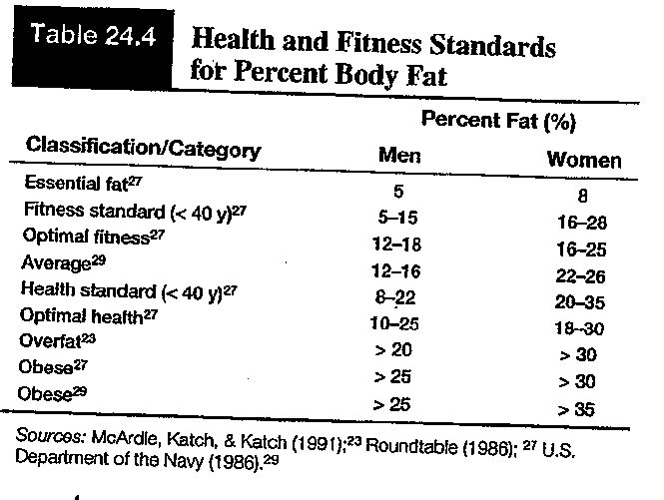

It is also important to remember that BMI is only one factor related to risk for disease. For assessing someone's likelihood of developing overweight- or obesity-related diseases, other predictors can be determined by taking girth measurements with a spring-loaded tape measure. These include:
- The individual's waist circumference (because abdominal fat is a predictor of risk for obesity-related diseases)
- Higher risk associated with >40 inches (men); >35 inches (women)
- Waist-to-hip circumference ratio (indicates android/gynoid body fat distribution and can also be related to increase with health risks and early morbidity)
When administering or suggesting anthropometric tests of body composition, marching band leaders need to be considerate of the sensitive nature of such assessments. Invasive physical testing or disclosure of results should be kept as private as possible, and band members should always be given options for consent just like other student-athletes (reference “NCAA Guidelines for Assessment of Body Composition” research link).

