COLD ENVIRONMENT STRESS

- The insulating properties of wet clothing are lost once it becomes saturated
- Extreme cold air does NOT damage respiratory passages (cold inhaled air quickly warms to >20 C)
- Clothing must be increased in cold environments when conditions are windy because wind speed causes an exponential increase in convective cooling

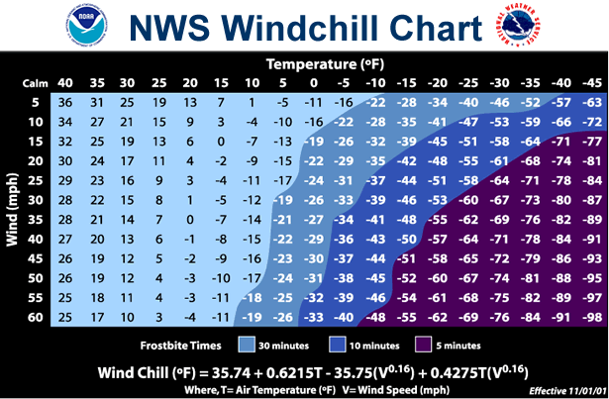
Effects of Hypothermia

Hypothermia
When exposed to cold temperatures, your body begins to lose heat faster than it can be produced. Prolonged exposure to cold will eventually use up your body's stored energy. The result is hypothermia, or abnormally low body temperature. A body temperature that is too low affects the brain, making the victim unable to think clearly or move well. This makes hypothermia particularly dangerous because a person may not know it is happening and will not be able to do anything about it, since when hypothermia sets in, there is a slowing of all body processes (metabolic, respiratory, etc.) For initial treatment: remove from cold and provide dry clothing, massage to stimulate blood flow, warm beverages…SLOWLY REWARM in serious cases!

Symptoms
Symptoms of hypothermia can vary depending on how long you have been exposed to the cold temperatures.

Early Symptoms
- Shivering
- Fatigue
- Loss of coordination
- Confusion and disorientation

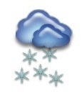

Late Symptoms
- No shivering
- Blue skin
- Dilated pupils
- Slowed pulse and breathing
- Loss of consciousness

First Aid
Take the following steps to treat an individual with hypothermia:
- Alert the supervisor and request medical assistance.
- Move the victim into a warm room or shelter.
- Remove their wet clothing.

Frostbite
Frostbite is an injury to the body that is caused by freezing. Frostbite causes a loss of feeling and color in the affected areas. It most often affects the nose, ears, cheeks, chin, fingers, or toes. Frostbite can permanently damage body tissues, and severe cases can lead to amputation. In extremely cold temperatures, the risk of frostbite is increased in workers with reduced blood circulation and among workers who are not dressed properly.

Symptoms
Symptoms of frostbite include:
- Reduced blood flow to hands and feet (fingers or toes can freeze)
- Numbness
- Tingling or stinging
- Aching
- Bluish or pail, waxy skin

First Aid
Individuals suffering from frostbite should:
- Get into a warm room as soon as possible.
- Unless absolutely necessary, do not walk on frostbitten feet or toes-this increases the damage.
- Immerse the affected area in warm-not hot-water (the temperature should be comfortable to the touch for unaffected parts of the body).
- Warm the affected area using body heat; for example, the heat of an armpit can be used to warm frostbitten fingers.
- Do not rub or massage the frostbitten area; doing so may cause more damage.
- Do not use a heating pad, heat lamp, or the heat of a stove, fireplace, or radiator for warming. Affected areas are numb and can be easily burned.
- Warm the center of their body first-chest, neck, head, and groin-using an electric blanket, if available; or use skin-to-skin contact under loose, dry layers of blankets, clothing, towels, or sheets.
- Warm beverages may help increase the body temperature, but do not give alcoholic beverages. Do not try to give beverages to an unconscious person.
- After their body temperature has increased, keep the victim dry and wrapped in a warm blanket, including the head and neck.
- If victim has no pulse, begin cardiopulmonary resuscitation (CPR).

Some final considerations…
- Subcutaneous fat serves to insulate periphery and attenuate decreasing core temperature
- Higher aerobic capacity & relatively larger muscle mass helps fight cold stress by increasing shivering response (shivering may increase metabolic rate by more than 5 kcal /minute)
- There are few proven human adaptations to chronic cold-stress

